01 Create a Repository
Start by creating a new GitHub repository that will hold the static website's source code.
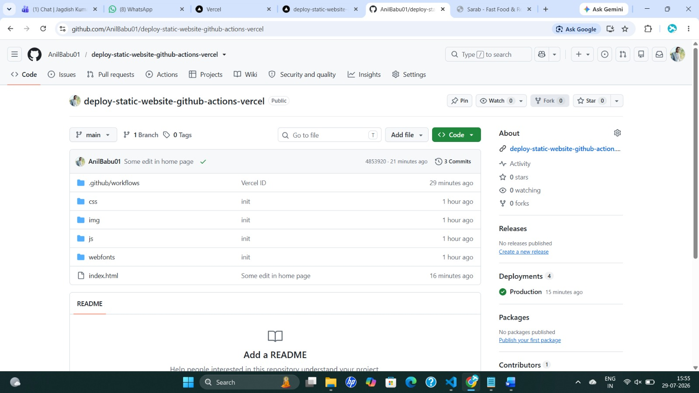
Figure 1 — GitHub repository created for the project
02 Add Remote and Push the Code
Initialize a local Git repository, connect it to the remote on GitHub, and push the initial commit.
$ git init
$ git add .
$ git commit -m "init"
$ git remote add origin https://github.com/AnilBabu01/deploy-static-website-github-actions-vercel
$ git push origin main
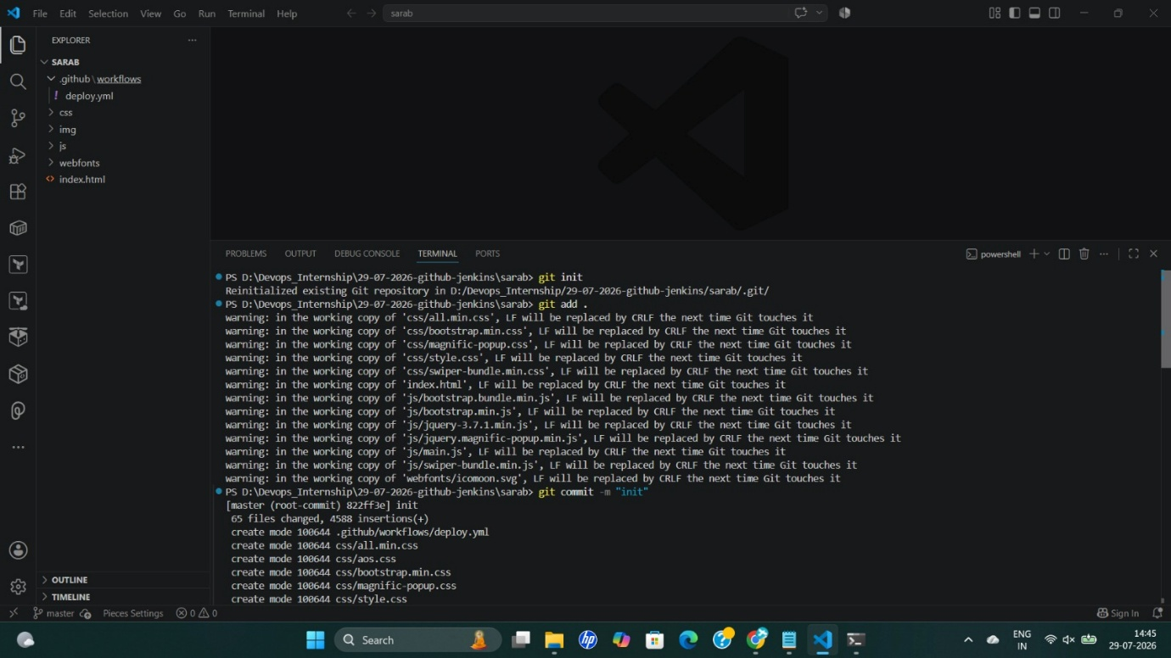
Figure 2 — Local repository pushed to GitHub
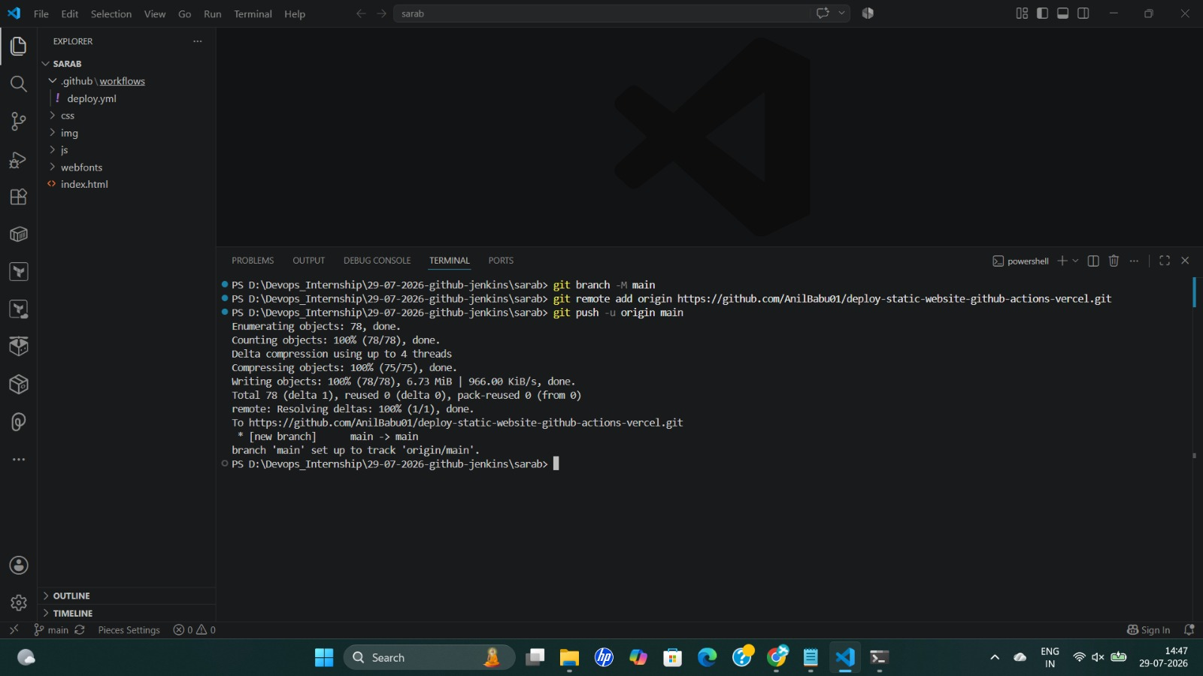
Figure 3 — Code visible in the GitHub repository
03 Create and Import the Project on Vercel
Create a new project on Vercel and import the GitHub repository. This links the repository to a Vercel project and performs the first deployment.
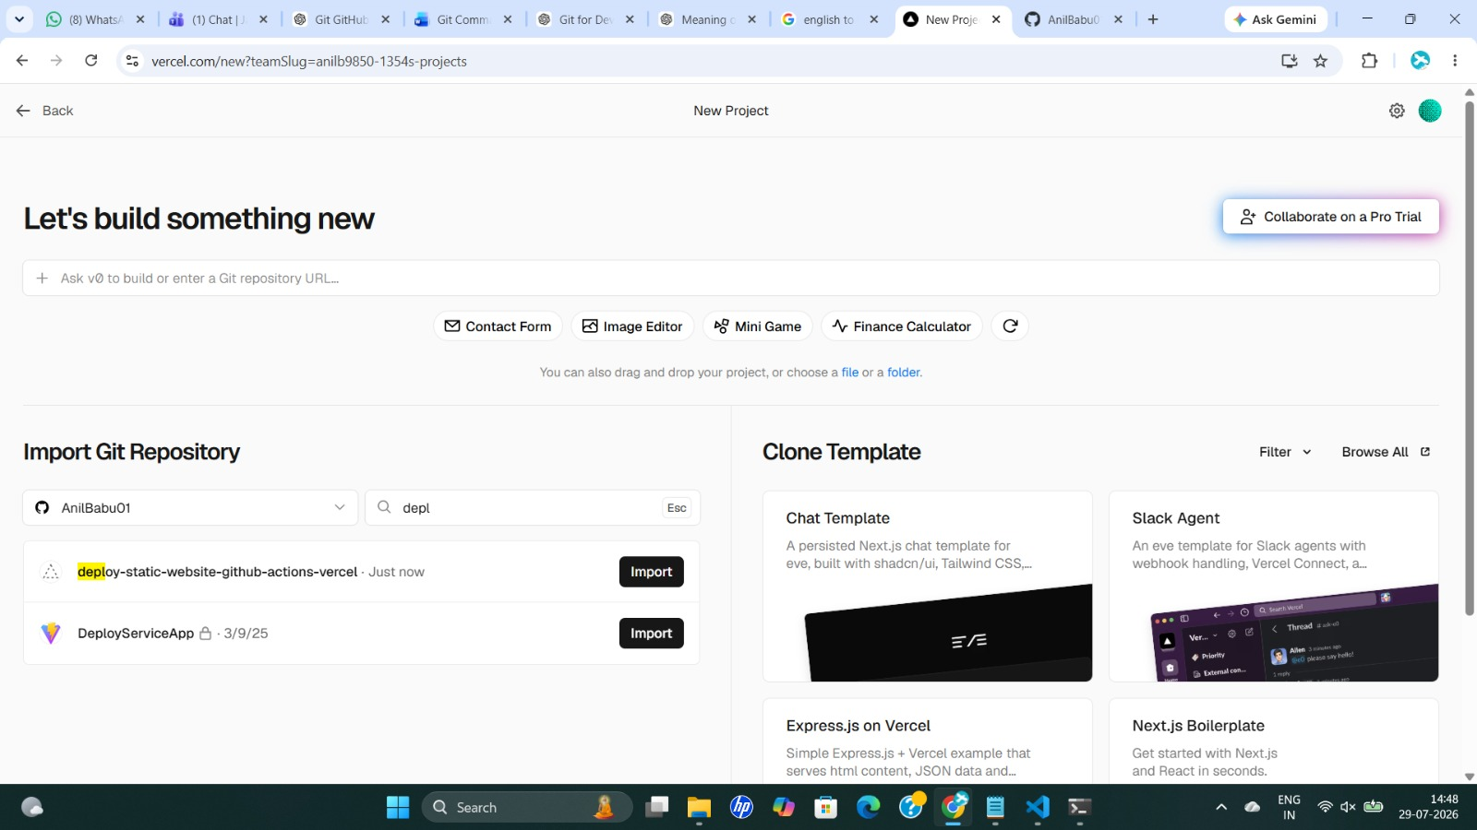
Figure 4 — Importing the repository into Vercel
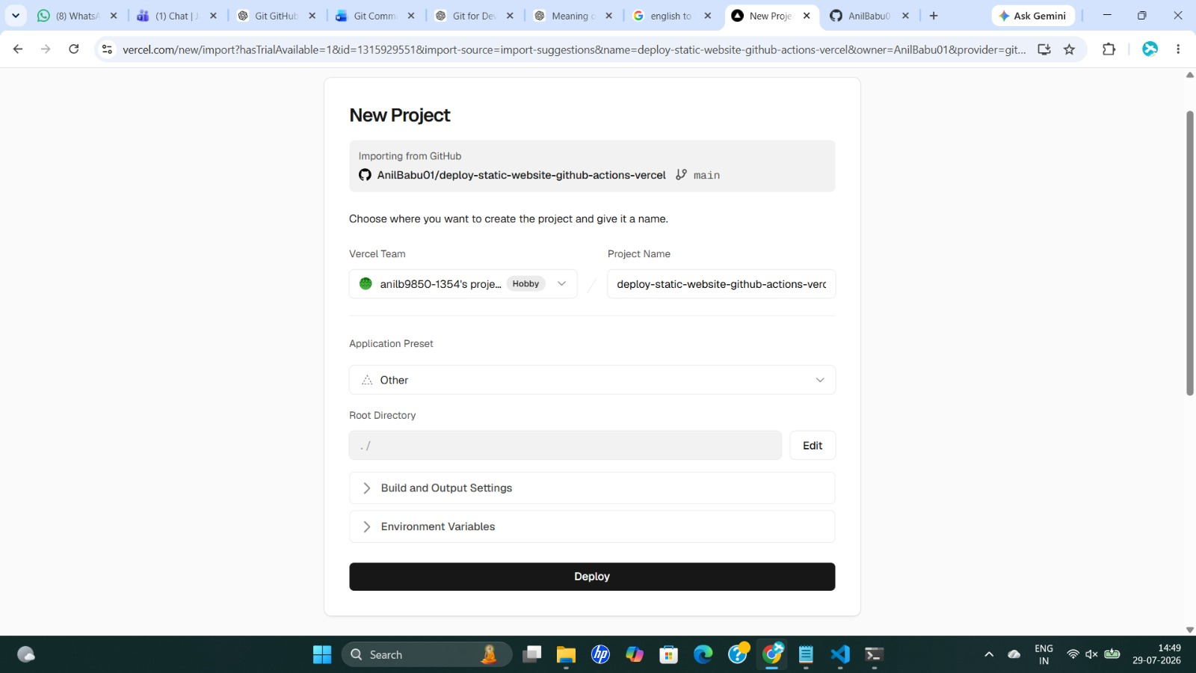
Figure 5 — Project successfully created and deployed
04 Add Vercel Secrets to the GitHub Repository
For GitHub Actions to deploy on Vercel's behalf, add the following as repository secrets under Settings → Secrets and variables → Actions:
✓ VERCEL_TOKEN — a personal access token generated from the Vercel dashboard
✓ VERCEL_USER_ID — the Vercel organization/account ID
✓ VERCEL_PROJECT_ID — the ID of the Vercel project created in Step 3
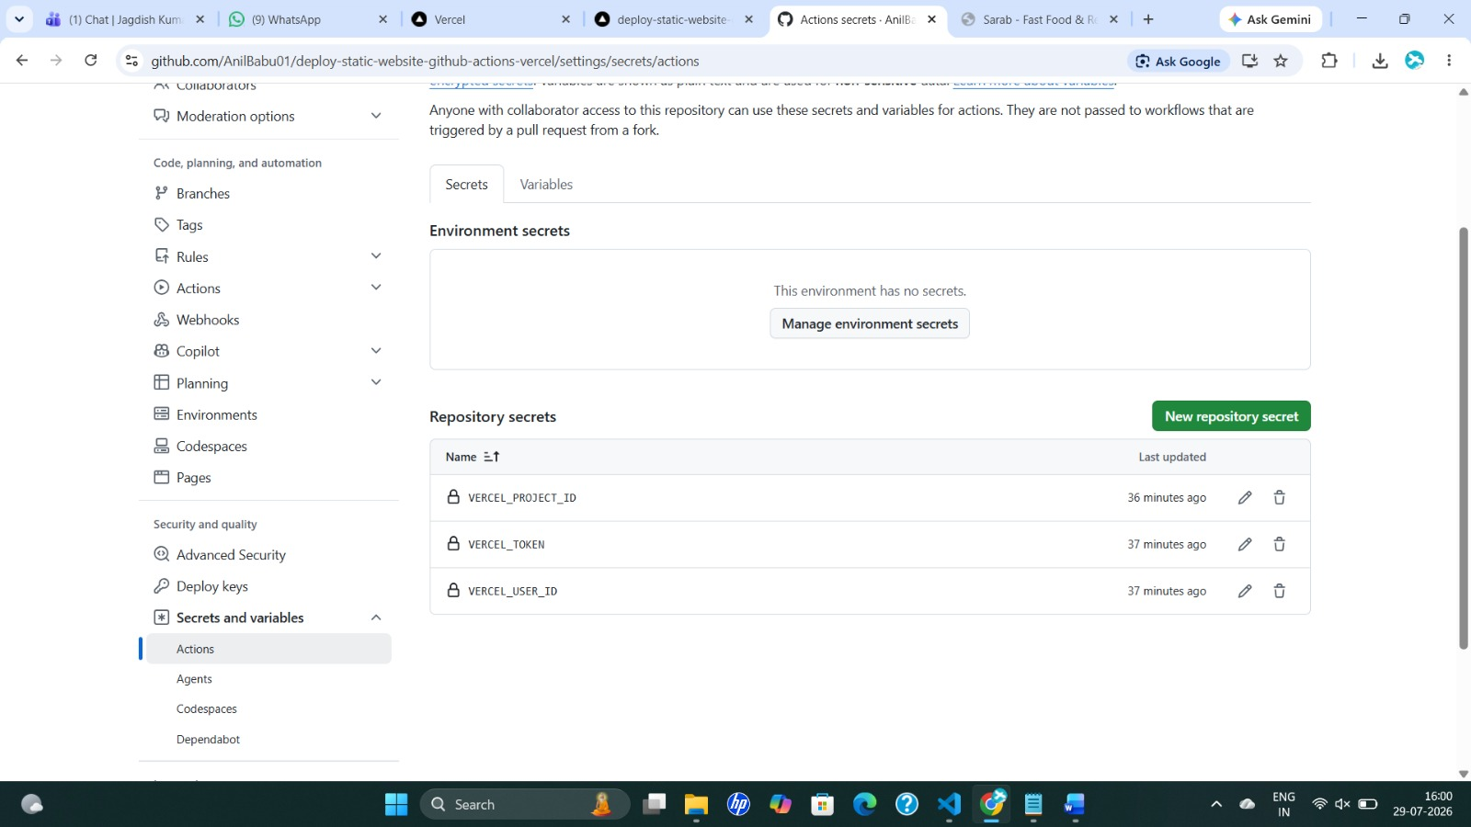
Figure 6 — Repository secrets and variables configured
05 Write the GitHub Actions Workflow
Create the workflow file at .github/workflows/deploy.yml. It checks out the code, installs the Vercel CLI, pulls the production environment configuration, and deploys straight to production.
.github/workflows/deploy.yml
name: Deploy Static Website to Vercel

on:
push:
branches:
- main

jobs:
deploy:
runs-on: ubuntu-latest
steps:
- name: Checkout Repository
uses: actions/checkout@v4

- name: Install Vercel CLI
run: npm install --global vercel

- name: Pull Vercel Environment
run: |
vercel pull \
--yes \
--environment=production \
--token=${{ secrets.VERCEL_TOKEN }}
env:
VERCEL_ORG_ID: ${{ secrets.VERCEL_USER_ID }}
VERCEL_PROJECT_ID: ${{ secrets.VERCEL_PROJECT_ID }}

- name: Deploy to Vercel
run: |
vercel deploy \
--prod \
--token=${{ secrets.VERCEL_TOKEN }}
env:
VERCEL_ORG_ID: ${{ secrets.VERCEL_USER_ID }}
VERCEL_PROJECT_ID: ${{ secrets.VERCEL_PROJECT_ID }}

06 Commit and Push a Change
Any change pushed to main now triggers the workflow automatically.
$ git add .
$ git commit -m "some changes"
$ git push origin main
07 Automated Deployment in Action
GitHub Actions picks up the push, runs the workflow, and deploys the updated static site to Vercel — no manual steps required.
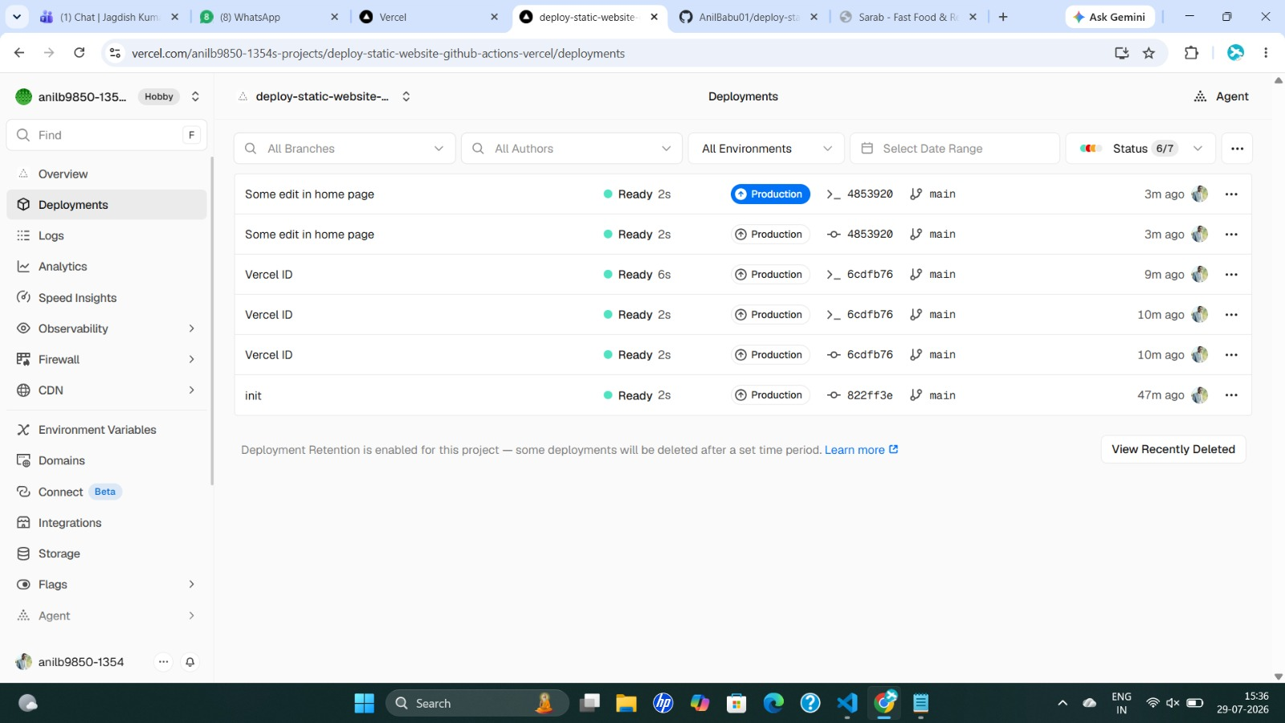
Figure 7 — GitHub Actions workflow running successfully

Figure 8 — Website live on Vercel
Live site
https://deploy-static-website-github-action.vercel.app/

